The Sources of Chinese Communist Party Conduct | Josh Rogin
May 4th, 2021
INTRODUCTION
Josh Rogin is a Washington Post foreign-policy columnist, CNN political analyst, and author of the book Chaos Under Heaven: Trump, Xi, and the Battle for the 21st Century. He has reported for Bloomberg View, the Daily Beast, Foreign Policy, Congressional Quarterly, Federal Computer Week, and Japan’s Asahi Shimbun. In April 2020, Rogin revealed diplomatic cables written by US diplomats in 2018 that reported safety and staffing concerns the diplomats had expressed after three visits in late 2017 and early 2018 to the Wuhan Institute of Virology. The cables reported that the WIV scientists claimed they did not have proper staffing and training to safely operate the Institute's Biosafety Level 4 (BSL-4) lab. The US diplomats also warned that the Institute was performing risky research on bat coronaviruses in their labs. The cables were seen by some US officials to support a hypothesis that the Wuhan Institute of Virology's research may have resulted in a lab accident that caused the outbreak of the COVID-19 worldwide pandemic.
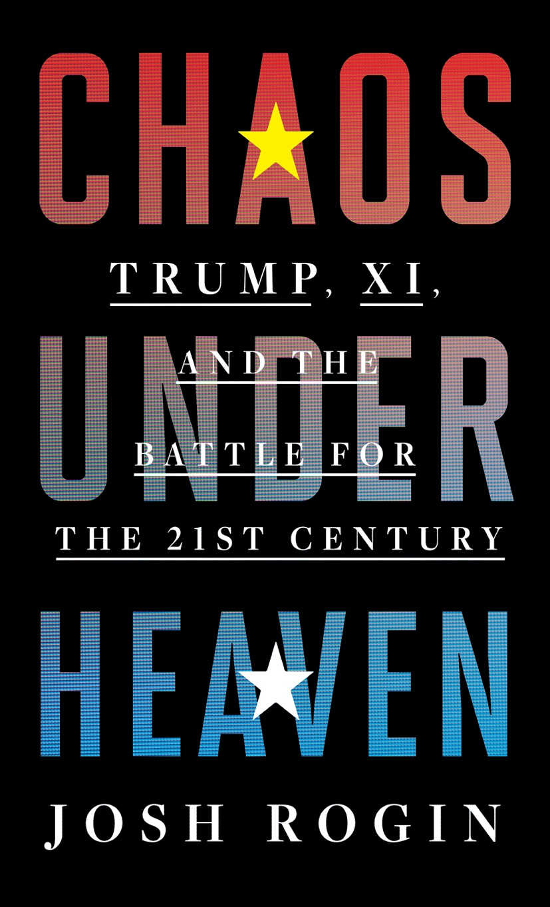
WHY DO I CARE?
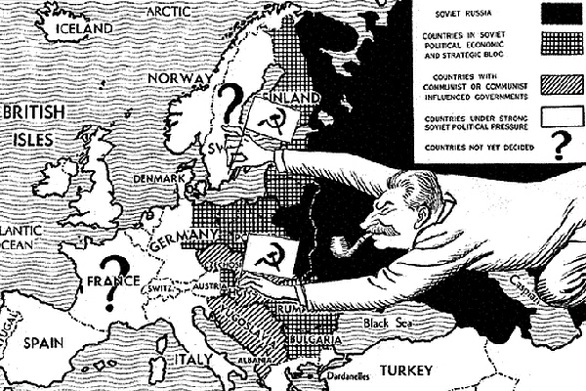
This is hands-down the best book I have read—and I’ve read many—on the subject of China and the Chinese Communist Party. It explains in incredible detail how the Chinese Communist Party works, its history, nature, motivations, operations, and objectives and it does so in a language that is both accessible and even, dare I say entertaining, because it’s full of personal anecdotes colored by Josh’s own reporting which is a testament to his skill as an investigative journalist and as someone with a reputation for breaking big stories. And while we don’t break any stories today, even for those of you who are regular listeners to this podcast and have heard any or all of our previous episodes on China, some of today’s episode is probably going to be news to you. In this conversation you’re going to learn how CCP influence operations work, who they target, and how they compromise influential individuals in both the public and private sectors, including CEO’s, University administrators, and elected officials, along with their spouses, friends, and family members. You’re also going to learn how the CCP uses tactics of blackmail, repression, and counterprograming, both within and outside of its boarders, in order to coerce and drown out its critics as part of a relentless culture of intimidation that is foundational to the party’s identity and history as an underground influence organization. Lastly, you’re going to learn why all of this matters to those of us living outside of China and how Western governments should respond to a threat that is no longer gathering but is in fact quite clear and immediate to those of us who have devoted time and attention to understanding this very important issue.
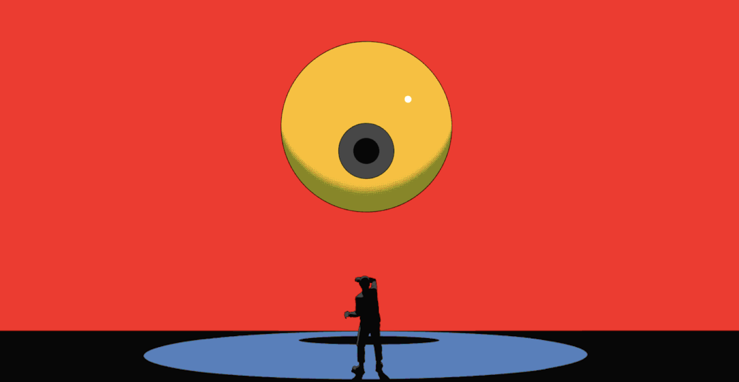
In the subscriber overtime, Josh and I will delve deeper into the financial side of this story, and how for years, the CCP has used US financial markets to fund the buildout of not only China’s military, but also its surveillance systems, including those used to monitor and control repressed minorities in the country’s autonomous regions, most notably in Xinjiang province where over 12 million Uyghurs are currently living under what international human rights organizations and governments agree are genocidal conditions that involve among other atrocities forced labor, compulsory reeducation, and coercive harvesting of hair and bodily organs. We also delve into Josh’s independent reporting on the origins of Covid-19, the troubling connections between the Wuhan Institute of Virology and America’s own public health officials, and why the lab-release hypothesis is actually much more credible than the mainstream media would have you believe. This is a serious conversation. No doubt about it. But everything that you are about to hear today has been widely reported on and is becoming increasingly well understood among those in positions of power within policymaking communities. The rise of China in this context signifies something very different than what most of us imagined and hoped for in the begging of the 21st century and demands an urgency and resoluteness that is arguably comparable to that last seen in our collective response to the Soviet threat enunciated most clearly in George Kennan’s seminal 8,000-word telegram to the US State Department in 1946. It is a challenge that we can and will overcome, but it’s time that we all get on the same page about what it means, what is required of us in order to confront it, and how our lives will drastically change as a result. Today’s conversation is meant to help you do precisely that.
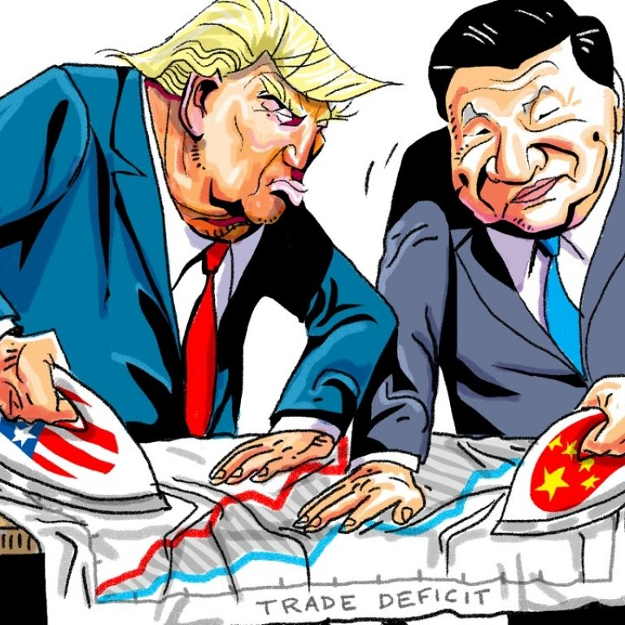
SETTING THE TABLE:
Chaos Under Heaven — Q: How did the idea for this book come about? Q: What does the book’s title, “Chaos Under Heaven,” refer to?
Awakening — You wrote that everyone you interviewed for your book had an awakening story; a moment in their personal or professional lives when they realized that the grand strategic competition between the United States and China was the most important foreign policy issue in the world and the most important project they would work on in their lifetime. This really resonated with me, as I’ve had a similar awakening. Q: What was your awakening story? Q: Did you have further awakenings after leaving your position at Rittenhouse Square? Q: Do we know if Trump had an awakening moment?
TRUMP ADMIN, FACTIONS, & POLICY SHIFT:
Policy Shift — Q: How big was the shift between US policy vis-à-vis China in every administration of the last 40 years (including the Obama admin) and Trump? Q: How shocking was this for the Chinese?
Trump “Shock” — You write that Donald Trump was “a president so unpredictable that he could scarcely have been imagined by foreign policy makers on either side before 2016.” Q: Just how shocking was Trump as an individual to the foreign policy establishment?
Trump Admin Factions & Infighting — Q: What can you tell us about the infighting and confusion within the Trump administration? Q: What were the different factions, where did their allegiances lie, and what were their motivations do you think? (e.g., Superhawks, Hardliners, Wall Streeter’s, Axis of Adults, Trump Family, & Billionaire Friends of Trump) Q: How did this compare to prior administrations? Q: What motivated Trump’s decision-making and positions on various foreign policy matters?
Bannon — Q: What are your thoughts on Steve Bannon? Q: What do you think of his world view? Q: How representative of reality is it? Q: What motivates him?
Trump Doctrine — Q: What were Donald Trump’s views on China before he got into the White House? Q: If you had to summarize what the “Trump Doctrine” would have been had the president articulated one, what would it be?
SOURCES OF CCP CONDUCT:
Explaining CCP & China’s Rise — You have probably had a lot of practice thinking about and trying to explain the rise of China in terms that most people can understand. Q: How do you tell the story of China’s rise? Q: How do you explain where and how this relationship came apart? Q: Have we just been lying to ourselves about what the CCP’s intentions were all along? Q: What are the CCP’s intentions?
Sources of CCP Conduct — In his long telegram, George Kennan described the Soviet strategy as one that involved a “cautious, persistent pressure toward the disruption and weakening of all rival influence and rival power.” Q: How do you think Kennan would describe the CCP strategy today? Q: What are the sources of CCP conduct? (its history, nature as an underground influence organization, and its dictatorial nature) Kennan also wrote that “the greatest danger that can befall us is in coping with this problem of Soviet communism, is that we shall allow ourselves to become like those with whom we are coping.” Q: Are we in danger of having this happen to us today?
CCP Image Sensitivity — Time and again, you see that entirely symbolic victories like preventing the naming of a street in Washington D.C. after a Chinese dissident or muzzling Houston Rockets GM Daryl Morey from speaking out on China’s clamp down in Hong Kong carry much more significance for the CCP than their equivalents would to the U.S. Q: What explains this? Q: Is this because the CCP knows it has a PR problem and is fighting an uphill battle on that front in western societies in order to alter public opinion?
Xi Jinping Outlook — Q: How do you think that Xi Jinping sees the world? Q: What informs your understanding of his view? Q: How well do his views align with those of the party? Q: Is the main difference between China’s leaders really about tactics and approach, and not so much on objectives, which align across leaders?
CCP Duplicity — Q: Are China’s leaders and its foreign policy more duplicitous than American foreign policy or are we just getting a taste of our own medicine? (i.e., the history of US foreign policy is full of examples of treachery and deceit) Q: Does this type of “moral hypocrisy” damage our credibility when trying to hold the Chinese accountable?
UNDERGROUND INFLUENCE ORGANIZATION:
Compromised Americans — Q: What are some examples of politicians in America who have been seriously compromised or whose family and friends have been seriously compromised by conflicting Chinese commercial or political interests? Q: Can you tell me more about Deng Murdoch, Elaine Chao, Montana Sen. Steve Daines, etc.?
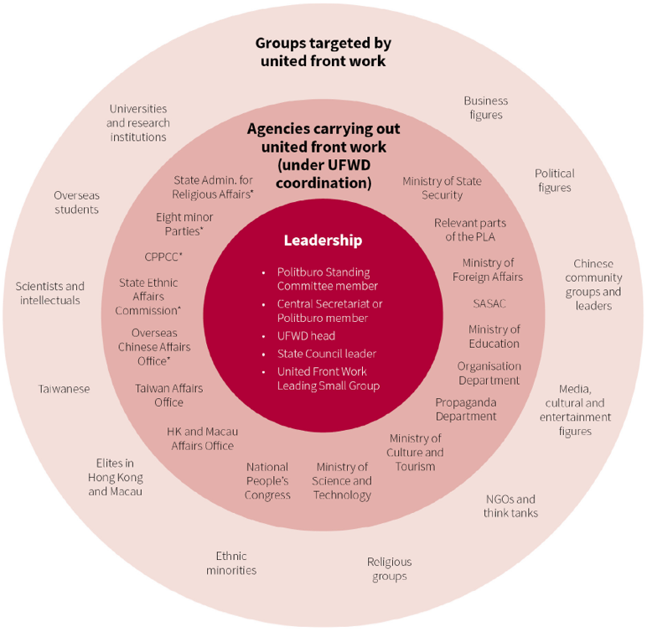
Influence Operations — Q: Can you break-down how these influence operations work and all the ways in which the CCP does this? Q: How do they use counterprogramming? Q: How do Chinese influence operations, espionage, and interference compare, both operationally and in terms of objectives to those of the Russians?
LBJ & CUSEF — Q: Can you tell the story of David Firestein’s attempt to use money from Tung Chee-hwa’s CUSEF to build out the China center at the LBJ School of Public Affairs at the University of Texas at Austin (and Joshua Eisenman’s concerns)?
Infiltrating University System — Q: How important is America’s university system to the CCP? Q: What has the party done to try and infiltrate America’s Universities? Q: To what end?
Forced Technology Transfer — Q: What does the term “forced technology transfer” mean, exactly? Q: How does forced technology transfer work?
FOREIGN INFLUENCE & SOWING WESTERN CONFUSION:
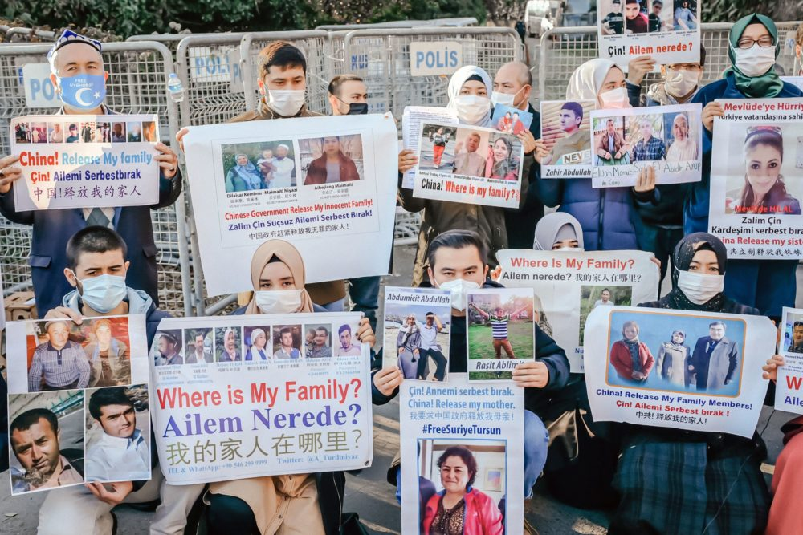
Moral Equivalency — Q: Do you think that there is an attempt by some in this country to try and create moral equivalency between US human rights abuses and those conducted by China?
Co-Opting International Institutions — Q: How much effort has China put into co-opting the United Nations, World Bank, World Health Organization, and other international organizations to help its development plans? Q: How do their efforts compare to those of other nations over the same period? Q: Why have they placed such importance on influencing these institutions?
Most Impressive — Q: Who among those you met in the course of your reporting impressed you most for his/her dedication to national security and his/her integrity and good intentions?
TOTALITARIAN & DICTATORIAL BY NATURE:
Uygur Genocide & Human Rights Crisis — Q: How much time have you spent learning the facts as they concern the situation in Xinjiang and with the Uyghur population there? Q: Is what make this story particularly awful the fact that it’s happening in the second biggest economy in the world?
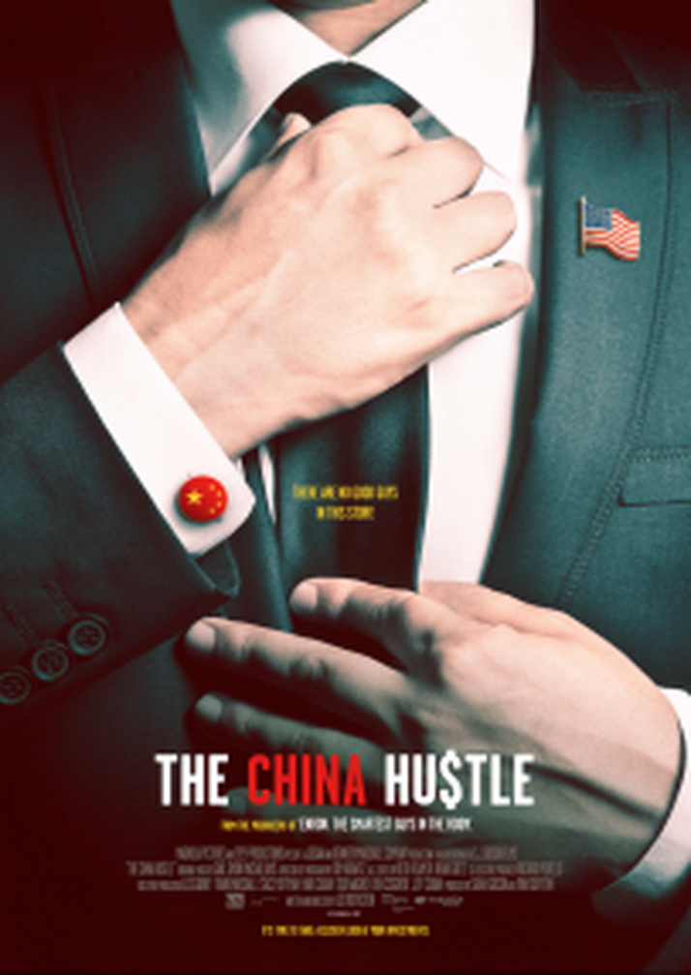
Case of Vera Zou — Q: How did you first meet Vera Zhou? Q: What can you tell us about her story? Q: Why did the University of Washington not try and help her despite her mother’s pleadings? Q: How common is this sort of thing in XinJiang? Q: How does her story compare to those of non-Uyghur’s living in other parts of China?
CCP FINANCIAL WARFARE & EXPLOITATION:
Financial Exploitation — Q: How has the CCP used US financial markets in ways that contradict and impede our own national security objectives? Q: How has it evolved its strategy in this regard over the years?
Regulatory Exemptions & Failed Oversight — Q: How much is the present situation the result of SEC regulatory exemptions and the lack of due diligence on Wall Street with regard to index funds?
E.O. 13959 — Executive Order 13959, signed in November 2020, had the stated goal of "Addressing the Threat From Securities Investments That Finance Communist Chinese Military Companies" The legislation is meant to prohibit any American investors worldwide from holding the securities of “Communist Chinese Military Companies” (CCMCs) that appear on the Department of Defense Section 1237 List (soon to be the Section 1260 List) effective November 11, 2021. Q: What is the status of this EO and does the Biden administration intend to keep it? Q: What are the key provisions of this order? Q: How does it treat subsidiaries?
Money Over Security & Values — Q: Is it the case that the U.S. now is subordinating national security concerns and fundamental values to potential investor losses?
Financial Leverage of CCP — Q: Is the CCP effectively exercising leverage over U.S. policy makers via an inordinate dependency by U.S. citizens on the prosperity of Chinese companies in their investment portfolios?
Virtuous Funding Cycle — Q: Does this create a virtuous cycle for the CCP that makes it exponentially difficult to extricate ourselves from serving as a massive source of funding for the very Chinese enterprises that are undermining U.S. and allied security interests and fundamental values?
Companies We Are Funding — Q: What are some of the companies (and their products and services) that Americans are unwittingly funding?
Arguments Against — Q: What sorts of arguments are made by people who oppose interventions like those you advocate for, which would divest Chinese companies deemed as risks to national security from using US capital markets to fund their development? (e.g., Chinese companies will simply go elsewhere for funding)
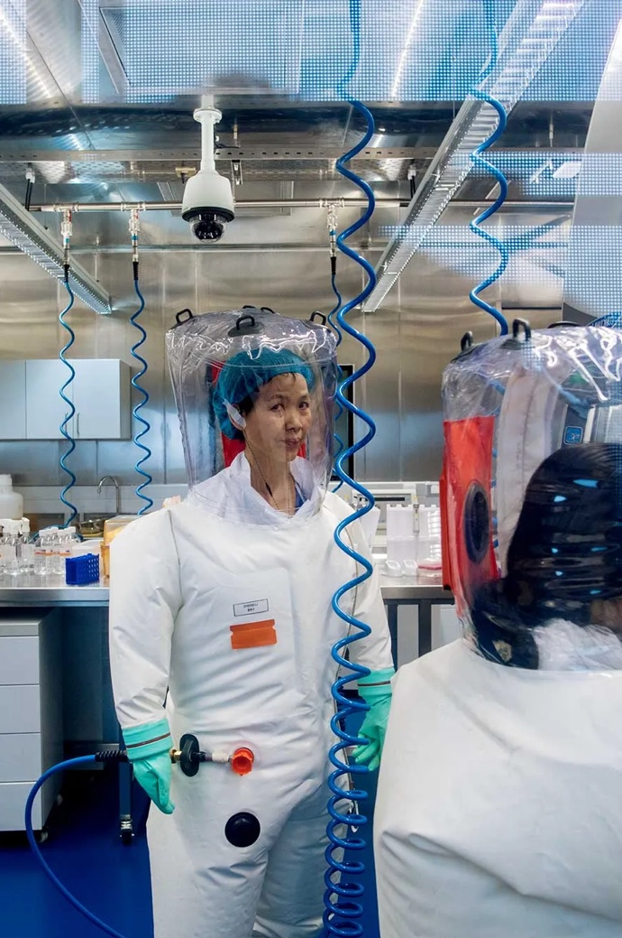
WUHAN INSTITUTE OF VIROLOGY & COVID-19:
Lab-Leak Hypothesis — Q: Can you walk me and my listeners through what you have learned about the lab-leak hypothesis? Q: Why should Americans care where the virus came from?
American Connections to Wuhan — Q: What is the connection between the gain-of-function research being conducted in Wuhan and US government research and funding?
Exploiting the Virus — Q: How did the CCP try and exploit the virus for political gain? Q: How was the CCP’s exploitation of this crisis any different than what the US would have done if it were in a similar position? Q: What can we learn about the CCP from this experience?
Backfired — Q: How did the CCP’s efforts to exploit this crisis backfire?
Waking Up — Q: Are Americans beginning to wake-up to this story? Q: Do you expect it to gain traction, or are there too many people in the US government who are incentivized to cover it up?
SOLUTIONS & WAY FORWARD:
New Alliance — Q: Do you believe that a new kind of alliance—like NATO, but for economic rather than military threats—is needed to respond to the kind of statecraft that China is practicing? A system, in other words, where participating nations would provide mutual support when China threatens one or more members with economic repercussions for political actions. That assistance could involve the imposition of tariffs on Chinese goods by all member nations; the creation of a pool of capital to help a targeted nation withstand Beijing’s pressure; the release of strategic reserves of essential materials, such as rare-earth metals, that China produces and could withhold; and other forms of collective economic defense.
National Defense Strategy — Q: Do you believe that we need a national defense strategy that takes a whole-of-government approach to engaging in strategic competition with China analogous to what we had during the Cold War? Q: What types of investments do you think we should be making?
Fiscal Investment — Q: Do you believe that domestic investment in not only key industries, but also in things like education should be on the table? Q: How much of America’s strength or weakness is a function of other factors like wealth and income disparity?
QUOTES:
Over the course of Trump’s presidency, awareness inside the US government and around the country steadily grew that Chin
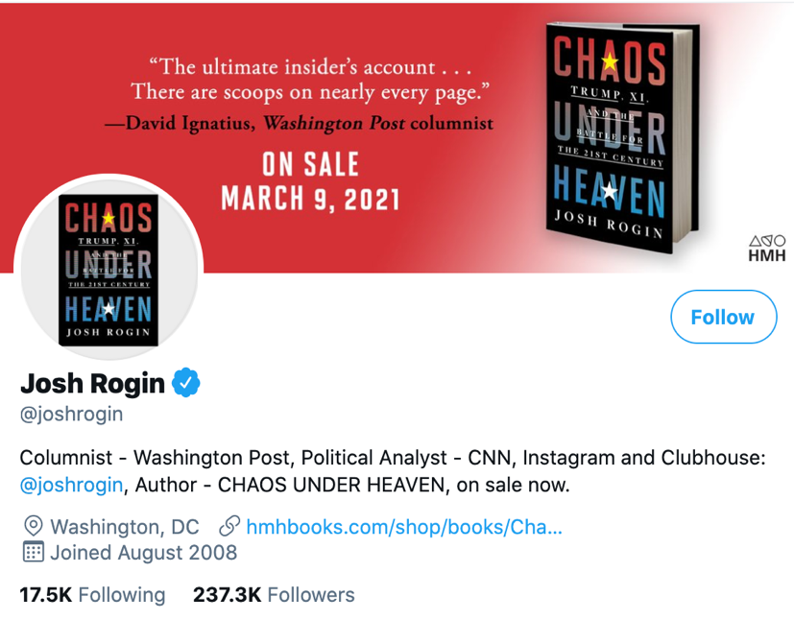
a’s rise and the Chinese government’s strategy play into all three of those dynamics. Put simply, a China that is militarily expansionist, economically aggressive, internally repressive, and increasingly interfering in democratic societies poses enormous challenges for the United States along with all of our allies, friends, and partners. The effects are already being seen in our national security, our investments, our industries, our schools, our media, and even our elections. — Josh Rogin, Chaos Under Heaven
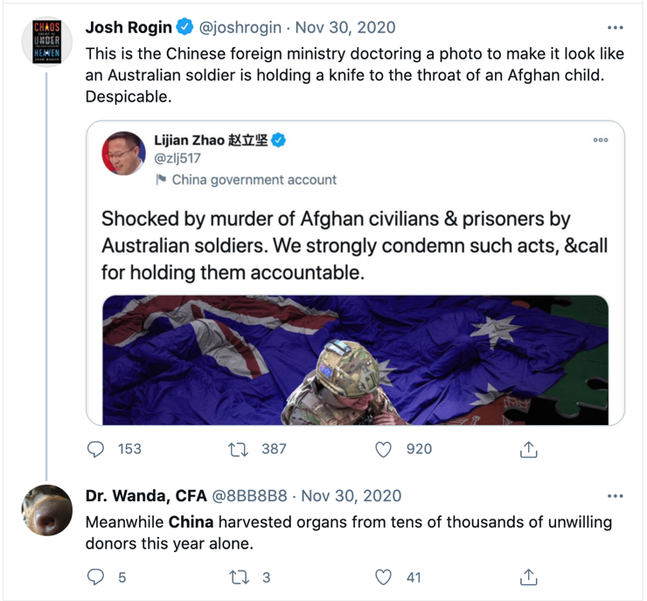
This is the story of how regular Americans in all walks of life over these four years gradually woke up to the fact that China’s rise and the CCP’s strategy are no longer faraway issues, but now pose direct and immediate challenges to their security, prosperity, freedom, and public health. This realization is not limited to Americans; people in countries across the world are undergoing it as well. The Trump administration played the first round of this new game, for better or worse. But future administrations will have to pick up where it left off and hopefully come up with a strategy that the entire country and our allies can join. Many career national security officials are already well aware of the threat and have long been calling for a broader response. “You have a bunch of liberal democracies that realize by 2016 that Xi Jinping is taking China backwards and we probably better start protecting ourselves. That’s the bigger story here,” said Turpin. “We needed a new strategic approach.” The Trump team mounted an imperfect and incomplete attempt to create that new approach. It will be up to their successors to continue, and improve, this vital endeavor. — Josh Rogin, Chaos Under Heaven
“My belief is pretty straightforward, that the CCP is exactly like Mussolini, Hitler and Tojo. These are gangsters, they are criminals. They think like criminals, they act like criminals and they need to be treated like criminals,” Bannon explained later. “This is very much like the 1930s . . . They are at war with us. They are at war and we are not. It’s pretty obvious.” Bannon believed the only way to save our country and the free world is to bring down the CCP as quickly as possible. “CCP delende est,” he loved to say, paraphrasing Cato the Elder, who ended every speech by declaring, “Carthage delende est,” or “Carthage must be destroyed.” — Josh Rogin, Chaos Under Heaven
Bannon believed China was key to his grand scheme to link the American Far Right and Far Left in a nationalist, populist political realignment. His goal was nothing less than to overturn the neoconservative, neoliberal globalist order—the same sect that Trump had run against. Both Bannon and the new president shared a dream of destroying the power of the political elite in both parties, and Bannon thought he knew how to make that dream a reality. One flaw in his plan, of course, was that the Far Left and the Far Right arguably have much more antipathy for each other than they do common interests. But Bannon believed they could be united on the China issue. — Josh Rogin, Chaos Under Heaven
The first thing he did was brush off the very first memo he had written about China for the Trump campaign that past November and share it with his new team. This twelve-page memo became the starting point for the NSC to figure out what a new US strategy should look like. It ended up having more influence on the Trump administration’s approach to China than almost any other single document. The memo was saved on Pottinger’s computer under the name “Bill’s Paper.” (There is no Bill; Pottinger used the name to throw off any per- son or entity who might be scouring his files surreptitiously.) It begins with the subtitle “A Balance of Power” and presents a set of concepts to explain the need for a new US approach toward China and how to get there. The paper argues that the peace and prosperity that Asia has enjoyed since World War II, which was made possible by US hegemony, was being threatened by three shocks: the rise of the People’s Republic of China, which is laboring to displace the United States in Asia and dissolve our alliances; the dramatic nuclear and missile technology advances by North Korea; and the rising sense among America’s Asian allies that the United States is withdrawing from its role as guarantor of their security and freedom. While the United States was distracted by wars in the Middle East and the Great Recession at home, Pottinger noted, China had quintupled its economy and built a world-class military, all without compromising its authoritarian political system or state-controlled economy. “As a result, U.S. hegemony as we knew it no longer exists in East Asia,” the memo argues. “What we have now vis-à-vis China is a dynamic and uneven balance of power (we have the military edge, they have the economic edge, and the political balance is roughly split). China’s aspiration is manifestly not to settle for a balance of power with the United States. Beijing’s intermediate-range goal is to achieve hegemony over its neighbors and the Western Pacific.” His claim about China’s imperial ambitions was not a mere assumption, Pottinger wrote, but rather the inescapable conclusion that any- one would reach if they were watching the Chinese Communist Party’s actions and listening to what it was saying — in its own language, to its own people. “The Party’s goal of hemispheric supremacy isn’t the whim of President Xi Jinping,” he wrote. “It stems from Party aspirations going back decades; Xi is merely accelerating the timeline. But the United States has a big vote in whether China achieves this aspiration.” — Josh Rogin, Chaos Under Heaven
“Taiwan is like two feet from China,” Trump told the senator. “We are eight thousand miles away. If they invade, there isn’t a fucking thing we can do about it.” If Trump had said those words publicly, he would have been abdicating forty years of American commitment to aid Taiwan in its defense, which is written into US law, and maintain the status quo that has kept the peace between Taiwan and China. The senator was speechless. This is what Trump really believed. He just didn’t give a shit. Nobody could know—although by that point in his presidency, it’s possible that nobody would have been surprised. — Josh Rogin, Chaos Under Heaven
“Hang on,” Trump said. “We’ve got to get the rapist.” “Excuse me?” Bannon said. “The rapist,” Trump repeated. “We’ve got to get the rapist . . . the guy who’s raping everybody. We’ve got to get him.” — Josh Rogin, Chaos Under Heaven
The issue of foreign governments’ influence operation
s inside the United States is difficult to talk about, because it’s designed to be difficult to talk about. It exists in a gray middle ground somewhere between overt soft power, propaganda, and espionage. It entails activities that are public in a sense but that conceal a covert purpose. They are meant to influence the domestic political and elite conversation about foreign policy without coming out and stating as much. This is why they are malign. This is why they are dangerous. — Josh Rogin, Chaos Under Heaven
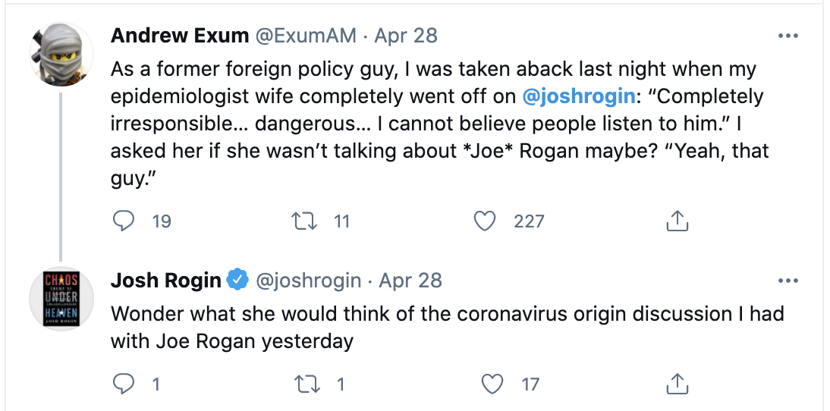
Moscow’s chief goal is to sow chaos into our political discussion and divide and inflame the democratic process in any way possible, to undermine the integrity of our system. In 2016, Russia could best achieve this by supporting Trump and attacking Hillary Clinton. But the truth is, Moscow played both sides at various times for sport and mischief. The Chinese government’s influence campaign inside the United States is a totally different animal. It’s a long-term project based on developing relationships over time with elites and interest groups the CCP believes it can leverage. It’s quiet, operating slowly and planting a thousand flowers that might bloom later. The scale is massive, involving huge net- works of proxies funneling billions into the political systems in foreign countries around the world. And it’s highly coordinated, led by a part of the party that dates back to Mao: the United Front Work Department. — Josh Rogin, Chaos Under Heaven
“Have you heard who McMaster is fucking?” Trump once asked no- body in particular during a crowded staff meeting in the Oval Office. “He’s gonna get us all in trouble if he can’t keep his dick in his pants.”
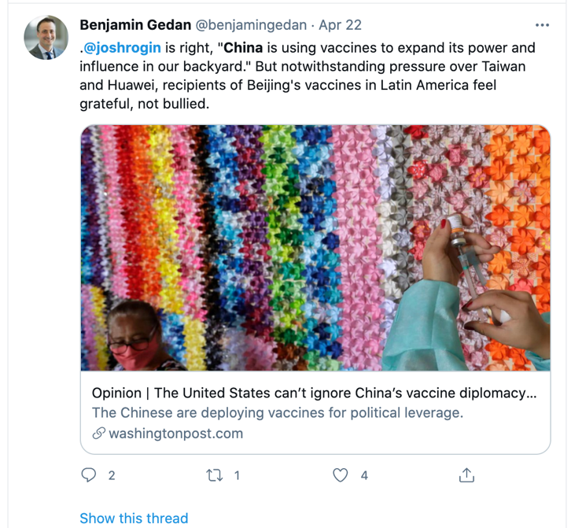
“Whatever why I’m so so missing Tony. Because he is so so charming and his clothes are so good. He has such good body and he has really really good legs Butt . . . And he is slim tall and good skin. Pierce blue eyes which I love. Love his eyes.” Blair has denied the claims. — Josh Rogin, Chaos Under
Heaven
Xi was so impressed with the performance of the CCP’s top official in Tibet, Chen Quanguo, that in 2016 he moved Chen to be the top CCP official in Xinjiang, where he was tasked with creating a similarly Orwellian system of repression for ethnic minorities there, including the region’s millions of Uyghurs. — Josh Rogin, Chaos Under Heaven
The CCP was waging a type of political warfare, he explained, a mix of information operations, influence peddling, propaganda, and old-fashioned espionage with a high-technology twist. It was directed at all parts of American society: our educational institutions, our technology labs, our media, our industry, our stock markets, and of course, our politics. By operating in the gray zones between soft power and hard power, between covert and overt operations, China’s leaders had been able to target for influence the sectors of American society whose strength underpins our national power and our national identity — the antibodies in our democracy that respond to threats. The CCP was not simply trying to compete with America’s vision for the global world order. Beijing was trying to change our ideas from within, using American institutions to promote the CCP’s interests. And our government had no idea what to do about that. “It’s a whole-of-society effort that Beijing is trying to mobilize,” Mattis told the group. “This comes from the party. It’s what the party does. And the question is how do we deal with this intrusive effort.” The primary goal of Beijing’s campaign was to promote the interests of the CCP and protect the party from criticism, much less resistance, from the United States or any other country. The second goal of this campaign, which served the first, was to undermine American institutions and, in so doing, weaken American democracy. Of course, the idea that China conducted influence operations inside the United States was not itself a secret. But Washington, along with most of the country, was slow to realize the sheer scope and scale of this new challenge. Sure, there were signs Washington was waking up. A bill introduction here, a think tank event there. It was akin to different members of a symphony orchestra arriving for a concert one by one. Many key instruments were still missing. There was no agreed-upon sheet music. And there was no conductor. — Josh Rogin, Chaos Under Heaven
“Mr. Bush, you have to admit it’s a pretty remarkable thing for a man just to go to a hotel room door and open it and have a woman standing there and have sex with her,” his wife’s lawyer said. “It was very unusual,” Bush replied. — Josh Rogin, Chaos Under Heaven
One must wonder how Neil’s brothers, former president George W. Bush and former governor Jeb Bush, feel about their brother allowing the CCP to use their father’s foundation as a platform for its propaganda. — Josh Rogin, Chaos Under Heaven
After she shook the hands of half a dozen people who stopped by our table to pay their respects, we spoke for about ten minutes. She never said, “off the record.” She asked me, “Josh, if you were to give advice to the Chinese leadership on how to handle these trade talks, what would it be?” I thought to myself, what an interesting construction for the question. Chao was asking me how to help Beijing deal with Washington, not how the Trump administration (in which she was transportation secretary) should deal with China. I played along. “I think I would tell them that this is their last chance to really make the changes Washington is demanding. If they don’t do that now, this town is going to run out of patience and things are going to get worse,” I said. I was trying to give her advice that, if passed on, would honestly reflect the mood in Washington, but I doubted that Beijing would heed it, even if Chao did pass it along. She seemed to take it in and we talked for a few more minutes. She was perfectly nice. When the New York Times published its explosive investigation into Chao’s ties to her family’s business and her family’s ties to the very top level of the CCP, her sister Angela suggested the reporting was motivated by their ethnicity. But if you read through the report, it’s clear why the Chao story is important. The Chao family is the only family to be considered American royalty and Chinese royalty at the same time. Their business interests and political activities are so intertwined, to say there’s no conflict of interest is not credible. — Josh Rogin, Chaos Under Heaven
…the long record of Chao helping her family business is too extensive to overlook. It calls into question why the Transportation Department under her watch proposed slashing budgets for American government mariner shipbuilding programs. Does it have anything to do with the fact that Angela and James Chao have served on the board of the holding company for China State Shipbuilding? Does it matter that Foremost ships don’t fly the US flag, to avoid operating and labor costs, but the US transportation secretary is supposed to be promoting the US flagging system? That’s why conflicts of interest are problematic. They present competing interests inside a person’s head and in their wallets. One of the families the Chaos have been close to for decades is none other than the family of Tung Chee-hwa. James Chao worked for Tung’s father, Tung Chao-yung, who founded the China Maritime Shipping Line. Fifty years later, Tung still ran that company, now called Orient Overseas Container Line. The families and the companies remain close. And until new details come to light about their relationship, it will continue to vex the Bingo Club—and anyone else who believes American officials should unequivocally put the country’s good over their family’s wealth, let alone the interests of another nation. — Josh Rogin, Chaos Under Heaven
[Sen. Steve] Daines’s trading of political favors to Beijing in excha
nge for economic rewards “confirms everything the Chinese believe about us and folks around the world, that anyone can be bought,” former US ambassador to Burma Derek Mitchell told me. “We’re only as strong as our weakest link, and that Daines would do this only encourages them to continue.” — Josh Rogin, Chaos Under Heaven
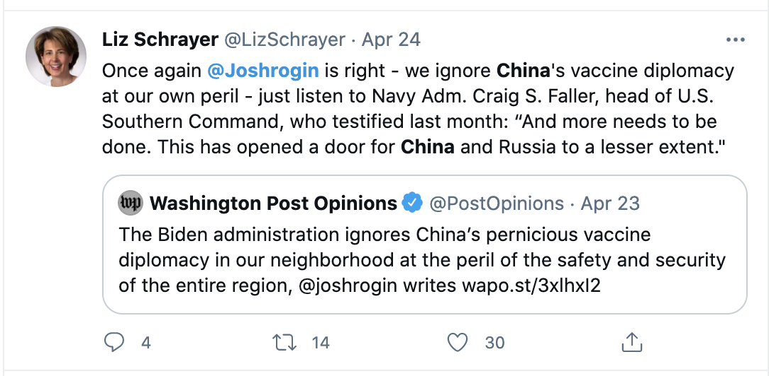
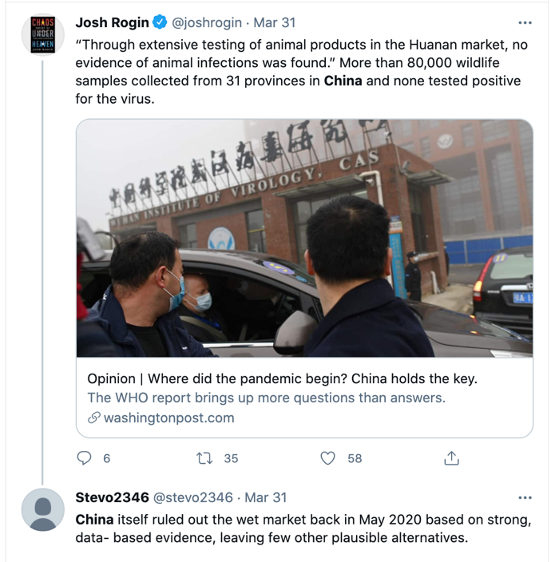
Nowhere were the problems posed by joint ventures in China during the era of military-civil fusion clearer than in the example of General Electric. GE has had a joint venture going back to 2011 with the Aviation Industry Corporation of China (AVIC), the state-owned aviation conglomerate, dealing with jet engines and avionics. Chinese commerce minister Chen Deming and then-US commerce secretary Gary Locke attended the public signing of the agreement in Chicago. Every year, the Pentagon puts out an annual report on China’s military power. Before the GE-AVIC joint venture, jet engines and avionics were both things this report identified for years as shortcomings in the technological advancement and ambitions of the People’s Liberation Army. After the GE deal, avionics fell off the Pentagon’s list as a Chinese shortcoming. GE essentially solved the People’s Liberation Army’s avionics problem. — Josh Rogin, Chaos Under Heaven
During the Trump-Xi dinner in Osaka, the subject of China’s “re-education camps” for Uyghur Muslims and other ethnic minorities in Xinjiang Province had come up. Evidence was piling up about mass detention, forced indoctrination, and other human rights violations against the over one million innocent people in these camps. Confronting Xi about these brutal abuses would not only be the moral thing to do; it also would ensure that Xi understood the West would not be able to ignore mass atrocities on such a large scale. But Trump didn’t care about the plight of the Uyghurs. Bolton wrote, “According to our interpreter, Trump said that Xi should go ahead with building the camps, which he thought was exactly the right thing to do.” — Josh Rogin, Chaos Under Heaven
Haley described the meeting as “bizarre.” The Chinese leadership had seen the outrage in the international community about the reporting on the internment camps, and this is what they had instructed their UN representative to tell people. Ma went on about how they were teaching the Uyghurs a trade, for their own good, so they can steer clear of a life of crime. — Josh Rogin, Chaos Under Heaven
“An authoritarian illiberal power is not going to want the world to be liberal and free. It wants an order that mirrors its own nature,” Nadège Rolland of the National Bureau of Asian Research told me. “So, what China wants for itself it wants for the rest of the world.” Beijing pretended they wanted to play along with our conception of the international order as much as they could, but this is over now, she said. China wants to shape that order and that system in a way that not only gives them a better say. It’s about changing the concepts and principles that undermine the current order because they threaten the CCP’s survival. — Josh Rogin, Chaos Under Heaven
The CCP views the American values of academic freedom and free expression (and other freedoms) as not only antithetical to its model but also as direct challenges to its governance—a threat, in fact, to what the party defines as China’s existential and ideological struggle with the West. Document 9, the 2013 memo approved by Xi Jinping and later revealed to the world, emphasizes the importance of controlling the public discussion and deems civil society, the free press, and the promotion of individual rights to be “political tools” used by “Western anti-Chinese forces.” As part of the CCP’s effort to “consciously strengthen management of the ideological battlefield,” the party has developed extensive programs to promote its political views in American academic institutions, blunt any criticism of CCP policies on campus, and stifle the free speech of Chinese students studying in the United States. — Josh Rogin, Chaos Under Heaven
In an April 2018 panel at the National Press Club, former Arizona congressman Matt Salmon, now Arizona State University’s vice president for government affairs, bragged (incorrectly) that the Pentagon was funding ASU’s Confucius Institute. He claimed that the Pentagon did not see the institute as a national security concern, and in fact used the Confucius Institutes to recruit Chinese speakers into the US government. Salmon also said those who are concerned about the institutes were engaged in “McCarthyism,” adding that “if it does pose a security threat, then the Department of Defense has made a big mistake by funding our program.” — Josh Rogin, Chaos Under Heaven
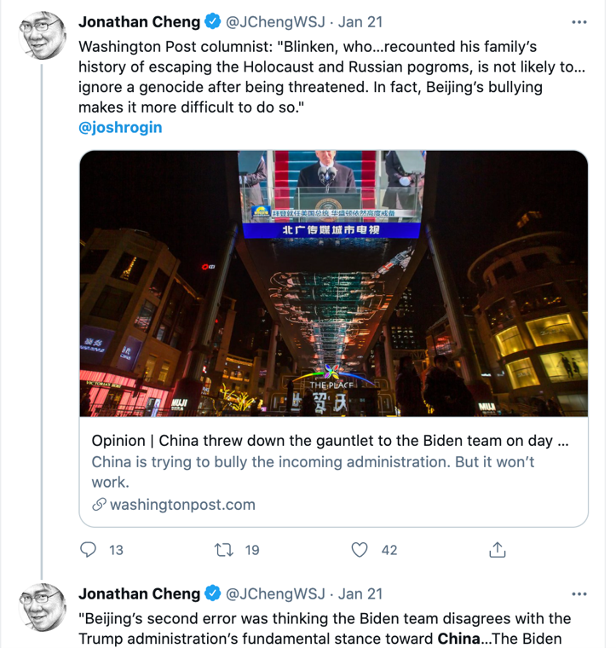
By inviting Confucius Institutes onto their campuses, in short, American academic administrators have allowed a generation of US university students to be taught as their primary source of information on China the regime’s official version of its history, ideology, and policies. This is a travesty, but it is one that is slowly being made right. Over the past six years, at least twenty-nine of more than one hundred US universities that had Confucius Institutes have closed them. This seems only fitting, given the counsel of Confucius himself in The Analects: “Not to act when justice commands, that is cowardice.” — Josh Rogin, Chaos Under Heaven
Confucius Institutes are not the only way in which the CCP makes its presence felt on American university campuses. Chinese Students and Scholars Associations (CSSAs) are student organizations on campus that are in many cases supported by the Chinese government, sometimes publicly. Individual CSSAs are often financially sponsored and monitored by Chinese embassy and consular officials, who have used these student organizations to support Chinese senior officials’ visits to US universities, facilitate trips to China, and mobilize support on campus for Chinese government objectives. — Josh Rogin, Chaos Under Heaven
After US stock market listings for Chinese firms began to attract too much scrutiny, Chinese firms found a way to raise billions from American investors without going anywhere near American markets. Beijing began to push major Wall Street index providers to include hundreds of Chinese companies in their offerings. These index providers were offshoots of major banks or financial firms whose business was to compile lists of companies based on extensive research that other investors could use to guide their investment decisions, either by licensing through the index providers or just by tracking the lists on their own. The index providers wielded huge influence in the global markets because their decisions caused a cascading effect on other investors — and also because they could include in their listings companies on any exchange, not just the American ones, meaning they were rainmakers for companies all over the world that wanted investment from Americans. Once Beijing realized that it could obtain US investments much more easily by listing Chinese companies on less scrupulous markets and then having the index providers bless these companies by adding them to their lists, it pushed that strategy with all its might — and the index providers played along. For example, the world’s largest index provider, MSCI, has been steadily increasing its holdings of Chinese assets, reportedly “after it came under heavy pressure by the Chinese government.” MSCI quickly began adding Chinese firms to its international index listings, particularly emerging market indexes, which had the effect of steering billions of US dollars toward those Chinese firms. Large investment vehicles like exchange-traded funds and mutual funds often track indexes like MSCI. This means that, whenever the index added Chinese firms, these large funds followed suit and took them on as well. Large institutional investors like pension funds and university endowments stocked up on these exchange-traded funds and mutual funds, often investing in them passively, which resulted in them taking on the risk of bad-actor Chinese firms. Investing in Chinese companies that were sanctioned by the US government, aiding the Chinese military, or contributing to human rights abuses would normally be seen as very risky. But when the index providers endorsed these firms, US investors’ dollars flowed to them. . . US investment funds worth nearly $14 trillion follow the MSCI indexes or use them as yardsticks for their investment decisions. That means asset managers all over the country are compelled to increase their holdings of Chinese stocks and bonds when MSCI does it. Millions of Americans, without doing anything, are all of a sudden betting on Chinese companies with their pension funds, mutual funds, and exchange-traded funds. — Josh Rogin, Chaos Under Heaven
…the companies the indexes were shoveling money into included companies that build weapons and ships for the PLA, companies that stood accused of cyber hacking, firms that are complicit in mass atrocities, and firms that are already sanctioned by the US government. The Wall Street firms weren’t just betting our money on China; they also were helping Beijing fund China’s expansion, which undermined the entire US government strategy to compete with Beijing and to maintain America’s technological and economic primacy. — Josh Rogin, Chaos Under Heaven
…by bypassing pathogens’ natural evolutionary cycles, these experiments create risks of a human-made outbreak if a lab accident were to occur. It was for this very reason the Obama administration issued a moratorium on gain-of-function experiments in October 2014. One such study at the University of North Carolina continued with permission despite the moratorium. Shi Zhengli was a contributor to that study, which used gain-of-function research to create a novel chimeric bat coronavirus that could more easily infect human cells. In late 2015, an article in Nature warned that it was too risky. — Josh Rogin, Chaos Under Heaven
What I found was that, just months into the pandemic, a large swath of the government already believed the virus had escaped from the WIV lab, rather than having leapt from an animal to a human at the Wuhan seafood market or some other random natural setting, as the Chinese government had initially claimed.
The hypothesis that the virus had emerged naturally, without any connection to the WIV lab, rested entirely on circumstantial evidence. — Josh Rogin, Chaos Under Heaven
In May, Chinese CDC officials declared on Chinese state media that they had ruled out the possibility that the seafood market was the origin of the virus, completely abandoning the original official story. But Beijing now claimed that neither the market nor the lab was the source. At the time of this writing, that is still their official position. — Josh Rogin, Chaos Under Heaven
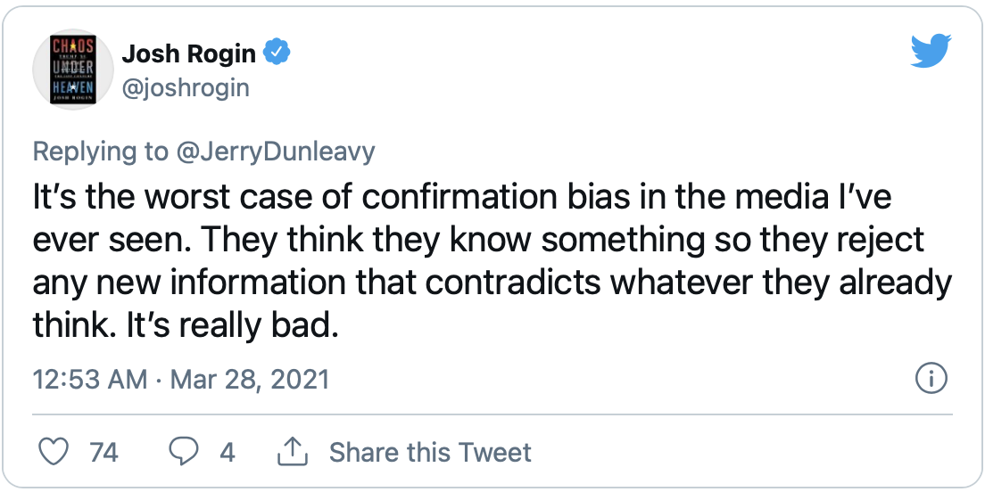
“If SARS-CoV-2 arose from gain-of-function research in a lab, it is entirely plausible, even likely, that an animal model involved in that work would have been humanized ACE2 mice,” said Richard H. Ebright, a microbiologist and biosafety expert at Rutgers University. “There is clear plausibility, there is not evidence. To get evidence would require either a confession or an investigation.” — Josh Rogin, Chaos Under Heaven
WIV explicitly had proposed using humanized ACE2 mice in the proposal for a grant they received from the NIH in 2014, which was granted through the Eco-Health Alliance, run by Peter Daszak.
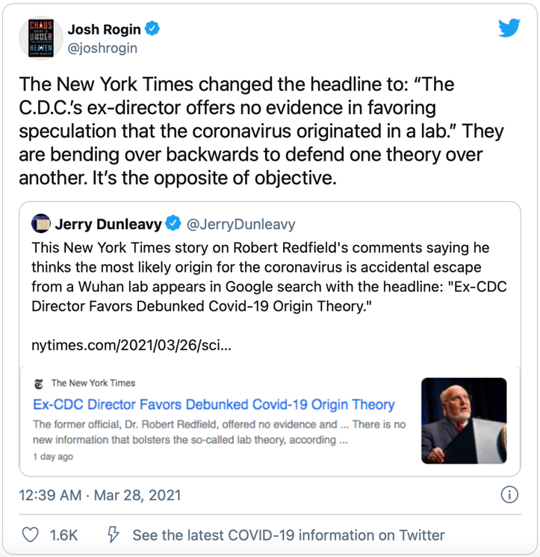
The Trump administration slowly but surely began taking away all of the special economic and trade benefits afforded to Hong Kong, nominally as a response to Beijing’s crackdown there. First, the administration ended Hong Kong’s right to import sensitive US technologies. Then, it ended Hong Kong’s special economic status altogether, promising to treat Hong Kong like any other Chinese city for the purposes of investments and trade. This was a drastic move, to be sure — akin to saving a drowning friend by pushing their head underwater. But the Hong Kong democracy leaders urged the Trump administration to take these moves, because they believed Beijing must not be allowed to crush Hong Kong’s freedom while still profiting off the island’s special status. — Josh Rogin, Chaos Under Heaven
“It became very clear to the American people with the Wuhan virus outbreak that China is not going to change its behavior. The Chinese have weaponized COVID, they are trying to take advantage of this crisis to displace the United States as a global power.” — NSA Advisor, Robert O’Brien
Rather than pursue open collaboration with the world’s scientists by making available all the experts and information they had accumulated, Chinese authorities banned all Chinese researchers from sharing coronavirus research without explicit government approval. When the US company Gilead sent Chinese researchers samples of their antiviral drug remdesivir for clinical trials using Chinese patients, the WIV tried to patent it. The US government also publicly accused the Chinese government of trying to steal vaccine and therapeutic research from US labs through cyber hacking and other means of intelligence collection. — Josh Rogin, Chaos Under Heaven
Around the region, China flexed its muscles at the very moment its neighbors were most vulnerable. Chinese troops crossed into India over the Himalayan border, provoking armed confrontations. The CCP’s rubber-stamp legislature passed a new national security law for Hong Kong, destroying the concept of “One Country, Two Systems” that Hong Kongers had depended on to maintain their freedom of speech and limited autonomy from Beijing. Immediately after passing the law, Hong Kong police began arresting high-profile members of the prodemocracy movement and raiding independent media organizations. China’s threats against Taiwan, its provocations in the South China Sea, and its repression of the Uyghurs all increased, too. The rest of the world was too distracted to object. — Josh Rogin, Chaos Under Heaven
For those in the American government who had yearned for an aggressive, US-led counterattack to China’s assault on the world order, this was nothing short of a godsend. But the United States was not fully able to take advantage of the bad will that China was building around the world—because back home, the Trump White House was creating too much bad will of its own. — Josh Rogin, Chaos Under Heaven
When Indiana GOP congressman Jim Banks put forward a resolution calling for an investigation into the virus’s origin, Representative Seth Moulton was the only Democrat to sign on. His fellow House member Democrat Judy Cheng called Moulton and told him he was supporting racism. He took his name off the bill. There were other signs that the coronavirus pandemic was destroying the budding bipartisanship in Congress on the China issue. The two parties had been working for over a year to plan a new China task force to coordinate policy and move important legislation. But the Democrats pulled out the night before the task force was set to be announced. — Josh Rogin, Chaos Under Heaven
Knowing that their time in power might be short, Trump officials raced to put in place as many new China policies as they could manage before the end of the year: The State Department declared Chinese state media outlets and the Confucius Institute headquarters in the United States to be “foreign missions,” meaning they had to report on their activities to the federal government, as did their hired lobbyists. A presidential proclamation was issued banning researchers from China in STEM fields if they had any association with the Chinese military. The Trump administration ordered the closure of the Chinese consulate in Houston, which was suspected of running extensive spying and research theft operations. The FCC named Huawei and ZTE as national security threats, banning the use of federal funds to purchase their equipment. — Josh Rogin, Chaos Under Heaven
“As Napoleon warned, don’t rouse a sleeping giant,” said Harvard professor Joseph Nye at the (virtual) Aspen Security Forum in August 2020. “But he was talking about China. We’re talking about the United States.” — Josh Rogin, Chaos Under Heaven
DEFINITIONS:
CFIUS — The Committee on Foreign Investment in the United States (CFIUS, commonly pronounced "Cifius" /ˈsɪfiəs/) is an inter-agency committee of the United States Government that reviews the national security implications of foreign investments in U.S. companies or operations. Chaired by the United States Secretary of the Treasury, CFIUS includes representatives from 16 U.S. departments and agencies, including the Defense, State and Commerce departments, as well as (most recently) the Department of Homeland Security. CFIUS was first established by President Gerald Ford's Executive Order 11858 in 1975, initially to study foreign investment. But in the 1980s, fear of Japanese investment (and in particular a proposed purchase of Fairchild Semiconductor by Fujitsu) led Congress to pass the Exon–Florio Amendment in 1988, which empowered CFIUS to reject deals. From 2013 to 2015, 20% of CFIUS's cases have to do with investment from China. CFIUS does not acknowledge which deals are under review, does not require the involvement of any of the parties of a deal, and does not publicly announce its findings.
FIRRMA — The Foreign Investment Risk Review Modernization Act (FIRRMA), grants CFIUS new powers over particular types of FDI that mainly concern Chinese investors. These include real estate investing, areas where minority investment through private equity provide access to US tech companies' business information, and US-Chinese joint ventures. CFIUS also gained more appropriations, staffing, authority to enforce a longer review period, and formalizes more thorough material agreement disclosure.
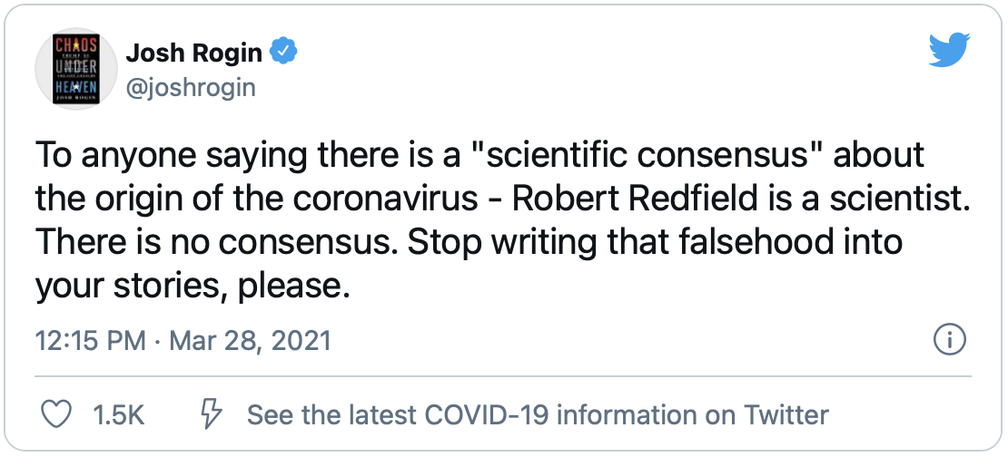
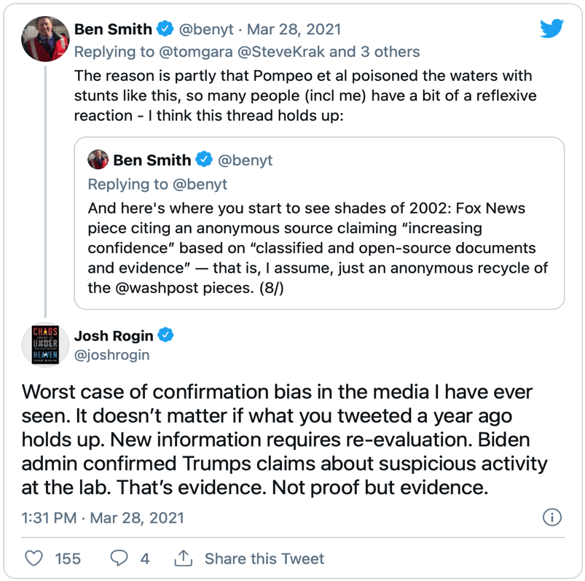
Special 301 Report — According to an April 29th, 2020 press release, the Office of the United States Trade Representative (USTR) released its annual Special 301 Report on the adequacy and effectiveness of trading partners’ protection of intellectual property rights and the findings of its Review of Notorious Markets for Counterfeiting and Piracy (the Review), which highlights online and physical markets that reportedly engage in and facilitate substantial trademark counterfeiting and copyright piracy.
“The Trump Administration is committed to holding intellectual property rights violators accountable and to ensuring that American innovators and creators have a full and fair opportunity to use and profit from their work,” said U.S. Trade Representative Robert Lighthizer. “Over the last year, USTR has secured strong and enforceable obligations on intellectual property in our historic agreements with China, Canada, and Mexico. The two reports issued today illustrate the Administration’s commitment to protecting intellectual property rights and combatting counterfeiting and piracy in online and physical markets.”
The Special 301 Report identifies trading partners that do not adequately or effectively protect and enforce intellectual property (IP) rights or otherwise deny market access to U.S. innovators and creators that rely on protection of their IP rights. Trading partners that currently present the most significant concerns regarding IP rights are placed on the Priority Watch List or Watch List. USTR identified 33 countries for these lists in the Special 301 Report:
- Algeria, Argentina, Chile, China, India, Indonesia, Russia, Saudi Arabia, Ukraine and Venezuela are on the Priority Watch List.
- Barbados, Bolivia, Brazil, Canada, Colombia, Dominican Republic, Ecuador, Egypt, Guatemala, Kuwait, Lebanon, Mexico, Pakistan, Paraguay, Peru, Romania, Thailand, Trinidad & Tobago, Turkey, Turkmenistan, the United Arab Emirates, Uzbekistan and Vietnam are on the Watch List.
USTR also announced Out-of-Cycle Reviews for Malaysia and Saudi Arabia.
These trading partners will be the subject of increased bilateral engagement with USTR to address IP concerns. Over the coming weeks, USTR will review the developments against the benchmarks established in the Special 301 action plans for those countries. For countries failing to address U.S. concerns, USTR will take appropriate actions, which may include enforcement actions under Section 301 of the Trade Act or pursuant to World Trade Organization (WTO) or other trade agreement dispute settlement procedures.
As part of the Special 301 review process, USTR invited public comments and held a public hearing that featured testimony from witnesses representing foreign governments, industry, and non-governmental organizations. USTR also offered a post-hearing comment period during which hearing participants could submit additional information.
The Review of Notorious Markets for Counterfeiting and Piracy highlights 38 online markets and 34 physical markets that are reported to engage in or facilitate substantial trademark counterfeiting and copyright piracy. This activity harms the American economy by undermining the innovation and intellectual property rights of U.S. IP owners in foreign markets. An estimated 2.5 percent, or nearly half a trillion dollars’ worth, of imports worldwide are counterfeit and pirated products.
The Review maintains its special focus on the distribution of pirated content and counterfeit goods online. This year, the Review contains an “Issue Focus” that explores the nexus between online piracy and malware. The Review also continues to discuss emerging piracy models, including illicit streaming devices, “stream-ripping,” and piracy portals and apps that cause major damage to the digital marketplace for legitimate music, movies, and television.
In addition, consistent with the April 2019 Presidential Memorandum on Combatting Trafficking in Counterfeit and Pirated Goods, this year’s Review has an expanded discussion on the challenges related to counterfeit and pirated goods on e-commerce platforms and third-party marketplaces. USTR will continue to address the issue of counterfeit and pirated goods with our trading partners and is considering seeking more information regarding e-commerce platforms, including those based in the United States, in future reports.
The Review does not constitute an exhaustive list of all markets reported to deal in pirated or counterfeit goods around the world, nor does it reflect findings of legal violations or the U.S. Government’s analysis of the general IP protection and enforcement climate in the country concerned. USTR initiated this Review on August 19, 2019 through publication in the Federal Register a request for public comments. The request for comments and the public’s responses are online at www.regulations.gov, Docket number USTR-2019-0013.
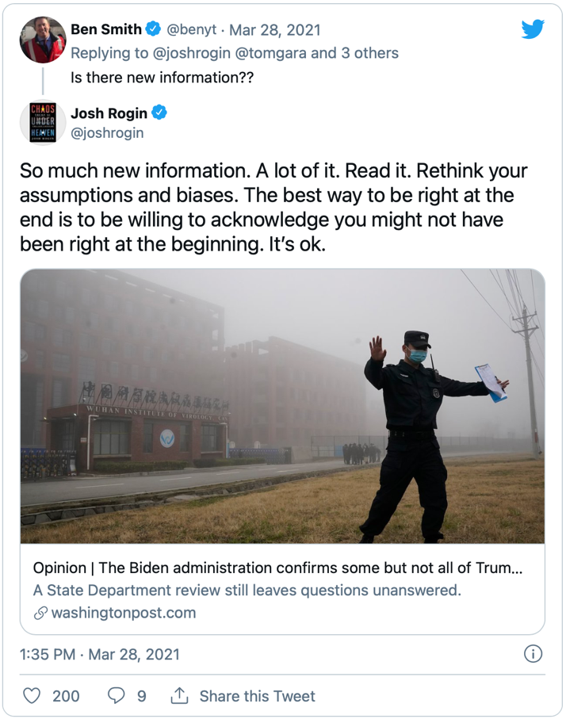
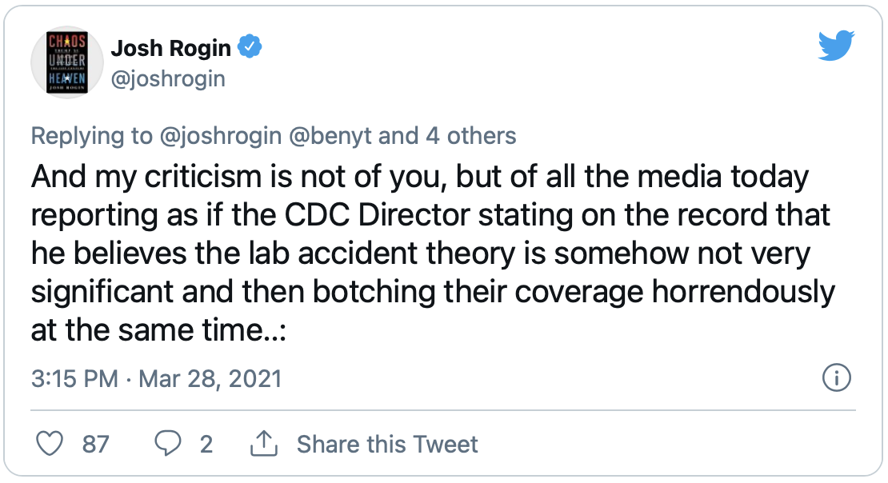
2021 NTE Report — On March 31, 2021, the Office of the U.S. Trade Representative (USTR), released the 2021 National Trade Estimate (NTE) Report. The report, which is the first issued under the Biden Administration, provides a detailed inventory of significant foreign barriers to U.S. exports of goods and services, investment, and digital trade. The NTE Report, which by statute, must be issued on or before March 31 each year, has served as a vehicle for first collecting a list of the most significant barriers to market access for US-based companies and then attacking particular barriers. It has become a valuable tool in helping administrations target their trade enforcement resources. The report classifies foreign trade barriers in eleven categories. These categories cover government-imposed measures and policies that restrict, prevent, or impede the international exchange of goods and services, unduly hamper U.S. foreign direct investment or U.S. electronic commerce. The categories covered include: Import policies (e.g., tariffs and other import charges, quantitative restrictions, import licensing, preshipment inspection, customs barriers and shortcomings in trade facilitation or in valuation practices, and other market access barriers) Technical barriers to trade (e.g., unnecessarily trade restrictive standards, conformity assessment procedures, labeling, or technical regulations, including unnecessary or discriminatory technical regulations or standards for telecommunications products) Sanitary and phytosanitary measures (e.g., trade restrictions implemented through unwarranted measures not based on scientific evidence) Subsidies, especially export subsidies (e.g., subsidies contingent upon export performance and agricultural export subsidies that displace U.S. exports in third country markets) and local content subsidies (e.g., subsidies contingent on the purchase or use of domestic rather than imported goods) Government procurement (e.g., closed bidding and bidding processes that lack transparency) Intellectual property protection (e.g., inadequate patent, copyright, and trademark regimes and inadequate enforcement of intellectual property rights) Services barriers (e.g., prohibitions or restrictions on foreign participation in the market, discriminatory licensing requirements or regulatory standards, local-presence requirements, and unreasonable restrictions on what services may be offered) Barriers to digital trade and electronic commerce (e.g., barriers to cross-border data flows, including data localization requirements, discriminatory practices affecting trade in digital products, restrictions on the provision of Internet-enabled services, and other restrictive technology requirements) Investment barriers (e.g., limitations on foreign equity participation and on access to foreign government-funded research and development programs, local content requirements, technology transfer requirements and export performance requirements, and restrictions on repatriation of earnings, capital, fees and royalties) Competition (e.g., government-tolerated anticompetitive conduct of state-owned or private firms that restricts the sale or purchase of U.S. goods or services in the foreign country’s markets or abuse of competition laws to inhibit trade) Other barriers (e.g., barriers that encompass more than one category, such as bribery and corruption. The release of the 2021 NTE Report follows the March 1, 2021 release of the 2021 President’s Trade Agenda and 2020 Annual Report. USTR plans to release its annual Special 301 Report on the adequacy and effectiveness of trading partners’ protection of intellectual property rights by April 30, 2021.
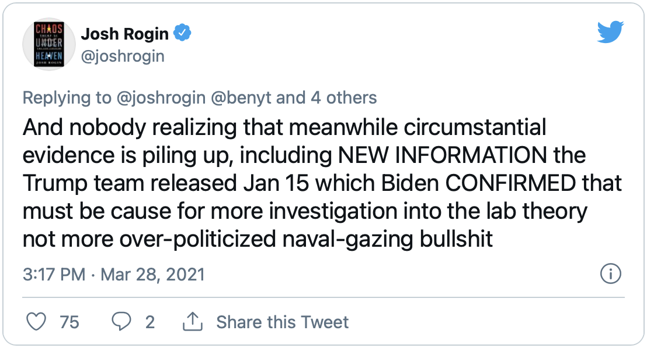
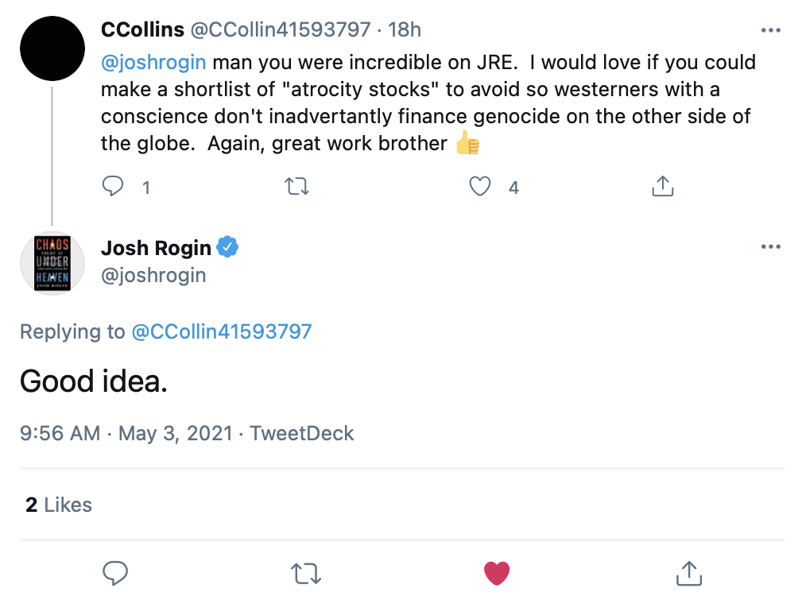
Chinese People's Political Consultative Conference (CPPCC) — The Chinese People's Political Consultative Conference (CPPCC), also known as the People's PCC, is a political advisory body in the People's Republic of China and a central part of the Chinese Communist Party's United Front system. The body traditionally consists of delegates from the Chinese Communist Party (CCP) and its allied front organizations, eight legally-permitted political parties subservient to the CCP, as well as nominally independent members. The CPPCC is chaired by a member of the Politburo Standing Committee of the Chinese Communist Party. The National Committee of the Chinese People's Political Consultative Conference ('National PCC') typically holds a yearly meeting at the same time as plenary sessions of the National People's Congress (NPC). The CPPCC National Committee and NPC plenary sessions are collectively called the Quanguo Lianghui ("National Two Sessions"). The organizational hierarchy of the CPPCC consists of a National Committee and regional committees. Regional committees extend to the provincial, prefecture, and county level. According to Article 19, Section 2 of the constitution of the CPPCC, the relationship between the National Committee and the regional committees is one of guidance and not direct leadership. However, an indirect leadership exists via the United Front Work Department at each level. The CPPCC is intended to be more representative of a broader range of people than is typical of government office in the People's Republic of China. According to Sinologist Peter Mattis, the CPPCC is "the one place where all the relevant actors inside and outside the party come together: party elders, intelligence officers, diplomats, propagandists, soldiers and political commissars, united front workers, academics, and businesspeople." In practice, the CPPCC serves "the place where messages are developed and distributed among party members and the non-party faithful who shape perceptions of the CCP and China." The composition of the members of the CPPCC changes over time according to national strategic priorities. Previously dominated by senior figures in real-estate, state-owned enterprises, and "princelings", the CPPCC in 2018 was primarily composed of individuals from China's technology sector.
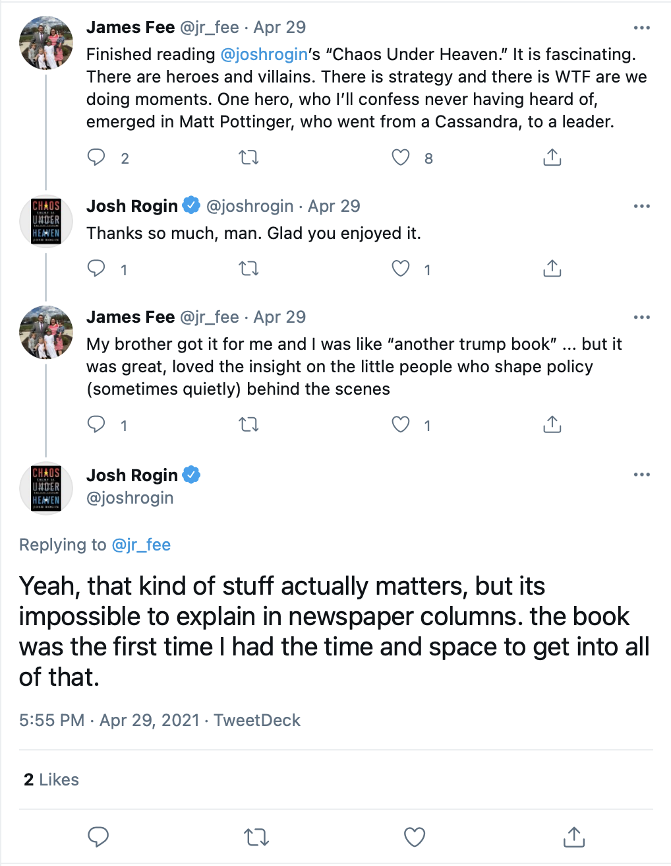
China–United States Exchange Foundation (CUSEF) — The China–United States Exchange Foundation (CUSEF) is a Hong Kong-based nonprofit organization whose stated aim is to encourage dialogue and exchanges between the people of the United States and China. CUSEF was founded in 2008 by Tung Chee-hwa, a billionaire, former Chief Executive of Hong Kong, and vice chair of the Chinese People's Political Consultative Conference, who remains the chairman of the foundation. CUSEF's governing board has included members such as Ronnie Chan, Elsie Leung, and Victor Fung. CUSEF donates to universities and think tanks in the U.S. while also sponsoring trips for journalists, students, and former U.S. officials and politicians to China to speak with officials. Critics state that CUSEF is a central part of the Chinese Communist Party's united front strategy of influence in the U.S.
United Front (China) — The United Front is a political strategy and network of groups and key individuals that are influenced or controlled by the Chinese Communist Party (CCP) and used to advance its interests. It has traditionally been a popular front that has included eight legally permitted political parties, the Chinese People's Political Consultative Conference (CPPCC), the All-China Federation of Industry and Commerce, the China Council for the Promotion of International Trade, the All-China Federation of Returned Overseas Chinese, and other people's organizations. Under Xi Jinping, the United Front and its targets of influence have expanded in size and scope. The United Front is managed primarily by the United Front Work Department (UFWD) but is not limited solely to the UFWD. It encompasses numerous subservient front organizations and their affiliates within China and abroad.

